**NHM 491 Directed Professional Individual Study Experience**

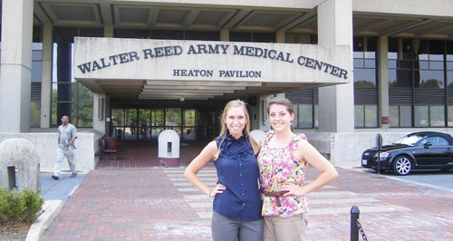 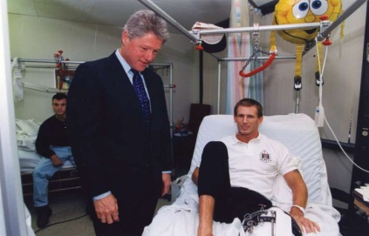



**Name:** Insert your name here  
**Facility:** Insert facility name and location here (eg. Walter Reed National Military Medical Center (WRNMMC), Washington DC)  
**Preceptor:** eg. Mrs. Kathy Brooks, MS, RD, Director Nutritional Services (name, credentials, job title)

**Summary of Experience:  
Brief info of the facility: eg. Type of facility, how big, who they serve, etc. (50-100 words)**

**Eg.** Named after Major Walter Reed, MD., a renowned US Army physician, it is the largest hospital in the country and provides health care services to all active duty military personnel and veterans, their spouses and families, and our Nations’ leaders. WRNMMC is comprised of over 8,500 staff, and serves over 1 million beneficiaries each year. It is also known as the President’s hospital. **(63 words)**

**Briefly comment on your experience: eg. Things you learned, things you did, liked from it. Purpose is for you to share your thoughts on your experience with other students. (250-300 words or more but limit to one page.)**

**Note: Customize this 1-page flyer. Be creative!**